1. **Agenda**: How to define different log levels for different classes so that logs from different classes can be logged with different levels.
2. 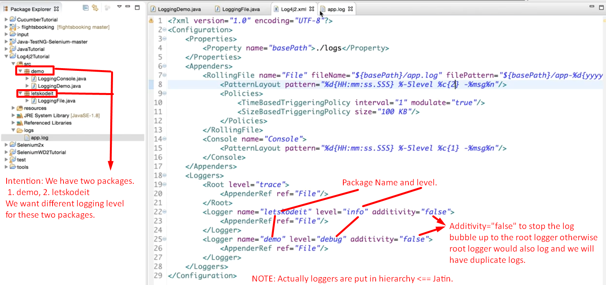
3. 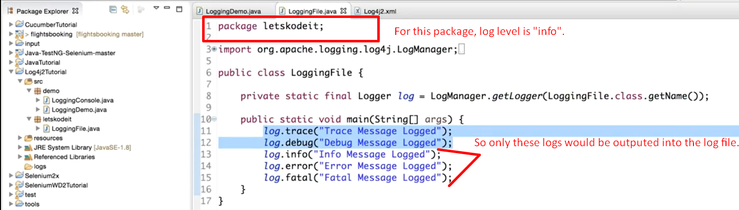
4. 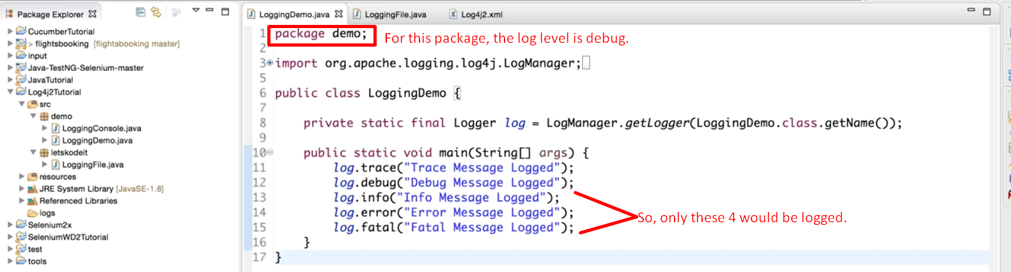
5. 